|  |  |
| --- | --- |
| Relative Dating | Absolute Dating |

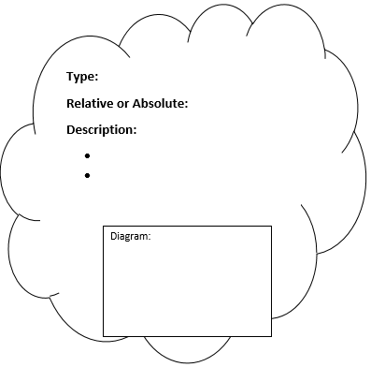

How to date like an archaeologist







**How to date like an archaeologist**